***Brief Introduction of Sr. Lecturer***

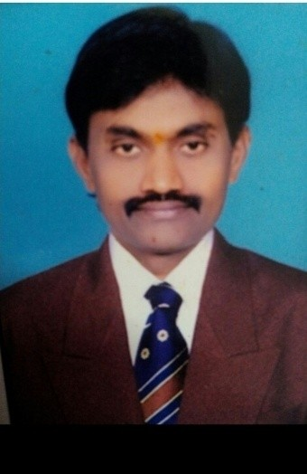

**Dr.P.RAMESHBABU, M.Sc, Ph.D**

**Lecturer in Chemistry Government Degree College**

**Uravakonda, Ananthapuram (District), A.P.**

Dr. P.Ramesh Babu, Lecturer in Chemistry, has completed his B.Sc from renowned institution in A.P, S.K.P.Government College, Guntakal (2002) and Post-Graduation from

S.K. University (2004). He was completed his research work and he got Ph.D award on 11th Jan, 2018 in R.U, Kurnool. He was invited as Chief Guest and Judge to NASA Program and Science Expo in Sri Chaitanya Educational Society, Guntakal, A.P.

Further He has **9** research papers in reputed International and National Journals and presented Research papers in **16** National and **06** International Seminars and 28 NationalWebinars and **23** International Webinars and participated in National Workshop (BARC) & State Level Workshops and delivered **7** Extension Lectures in various Institutions.

Besides, he has been active in academic up gradation of his pursuits with **5** FDP (Faculty Development Program) and STTP (Short Term Training Program) and Orientation Programs (LMS). He has number of successful students in IITs, NITs, Medical Colleges and Central Universities and State Universities, actively engages students in academic brilliance through ICT, and Curricular and Co-curricular activities like Assignments, Quizzes, Group Discussions, Field Trips and Regular Tests.

**PERSONAL PROFILE**

**Dr.P.RAMESH BABU, M.Sc., Ph.D**

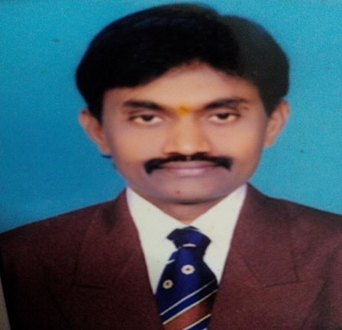

**Lecturer in Chemistry, Government Degree College,**

**Uravakonda, Ananthapuramu (District),**

**Andhra Pradesh, India.Mobile:9848649017**

**Email:**[**rb07857@gmail.com**](mailto:rb07857@gmail.com)

1. **AcademicQualificationsandOtherdetails:**

Subject : **Chemistry**

Highest Educational Qualification : **M.Sc., Ph.D**

Employee CFMS ID : 1000051243

Date of Birth : 25/02/1977

Social Category : OC

Religion : Hindu

Gender : Male

1. **Date of Joining service as :**
   1. Lecturer in Degree College : 05/08/2005
   2. In Government Degree College, Uravakonda : 02/07/2022
2. **AwardsandAchievements :**

* Actively Participated in 80th BRNS-IANCAS National Work Shop(6 Days) on Radiochemistry and Applications of Radioisotopes (**BARC),** 5 to 10th Nov, 2012andIgot 3rd Prize
* Participated in preparation of Patient paper on Petro Chemicals,2017
* Doctorate of Philosophy from Rayalaseema University in 2018
* Chief Guest and Advisor on Science Expo-2019 in Sri Chaitanya School(Branch-2), Guntakal
* Chief Guest on NASA Project,2019 in Sri Chaitanya Techno School,Guntakal
* ChiefGuestonScienceExpo-2020inSriChaitanyaTechnoSchool,Guntakal

1. **EducationalDetails:**

|  |  |  |  |  |  |
| --- | --- | --- | --- | --- | --- |
| **Class** | **Name of the Institution and Place** | **From** | **To** | **% of marks Division** | **Board/University** |
| SSC | Railway High School (TM),Guntakal,  Anantapur (District),A.P. | 1992 | 1993 | 47 | Board of SecondaryEducation,  Govt.ofAndhraPradesh |
| Inter | S.K.P.Govt. Junior College, Guntakal,  Anantapur (District), A.P. | 1994 | 1996 | 53.4 | Board of IntermediateEducationGovt.ofAndhra  Pradesh |
| UG | S.K.P. Government Degree College,  Guntakal, Anantapur (District), A.P. | 2000 | 2002 | 59.5 | Sri Krishna Devaraya  University, Ananthapur, A.P. |
| PG | Sri Krishna Devaraya  University, Anantapur, A.P. | 2002 | 2004 | 65.02 | Sri Krishna Devaraya  University, Anantapur, A.P. |
| Ph.D | Rayalaseema University,  Kurnool,A.P. | 11/01/2018 | | | Rayalaseema University,  Kurnool, A.P. |

**API/ASARScore:**

|  |  |  |  |  |  |  |  |
| --- | --- | --- | --- | --- | --- | --- | --- |
| **2014-15** | **2015-16** | **2016-17** | **2017-18** | **2018-19** | **2019-20** | **2020-21** | **2021-22** |
| Good | Good | Good | Good | Good | Good | Good | Good |

**PapersandSectionshandled(2019-20)**

|  |  |  |
| --- | --- | --- |
| **Course** | **Medium** | **TitleofthePaper** |
| B.Sc | TM | IYearI &II Semester: Paper–1&2 |
| B.Sc | TM | IIYearIIISemester:Paper -3 |
| B.Sc | EM | IIIYearVISemester:Paper–VII-BEnvironmentalChemistry |
| B.Sc | EM | III YearVI Semester : Paper – VIII-C3Pharmaceutical&MedicinalChemistry |
| B.Sc | TM | III YearVI Semester : Paper – VIII-C3Pharmaceutical&MedicinalChemistry |

1. **StateLevelseminarsattended:**

|  |  |  |  |  |
| --- | --- | --- | --- | --- |
| **S.No** | **State**  **Level** | **Institution/place** | **Date** | **TitleofthepaperPresented** |
| 1 | **StateLevel** | S.K.P. Government Degree College, Guntakal | 28th June,2012 | Great Features of Higher Education in 21stCentury |
| 2 | **StateLevel** | Andhra University, Visakhapatanam | 10th Oct,2015 | Quality Enhancement in Government Degree College-Role of Teachers |

1. **Nationalseminarsattended:**

|  |  |  |  |  |
| --- | --- | --- | --- | --- |
| **S.N** | **National** | **Institution/place** | **Date** | **TitleofthepaperPresented** |
| 1 | National | TwoDayUGCAPSHE  National Seminar on Need for Reform: Curricular at Aspects UG Level in Andhra Pradesh, S.K.P. Government Degree College, Guntakal | 26th& 27Feb,2009 | Participated in Need for Reform: CurricularatAspectsUGLevelinAndhraPradesh |
| 2 | National | National Seminar on Modern Trends in Green Chemistry, S.V.G.MGDC,  KALYANDURG | 9&10  Sep,2011 | Lithium Chloride as Efficient catalyst for the Synthesis of Quinaline Derivatives via the use of Microwave Irradiation |
| 3 | National | National Seminar on Chemistry and Global Perspectives, S.K.  University, ANANTAPUR | 24to26  Oct,2011 | Synthesis Characterization of Pyrazole, Indole, Di-peptide Heterocycles |
| 4 | National | National Seminar on Frontiers of Material Science, S.V.G.MGDC,  KALYANDURG | 17&18  Sep,2012 | Synthesis Characterization of Novel Mannich Bases containing Pyrazole, Indole, Di-peptide Heterocycles |
| 5 | National | National Seminar on Recent Developments in Electro Analytical (RDET-2012) Techniques, S.K.  University, Anantapur | 5th& 6thOct,2012 | Synthesis Characterization of Novel Mannich Bases containing Pyrazole, Indole, Di-peptide Heterocycles |
| 6 | National | National Seminar on Environmental Governance, S.V.G.MGDC,  KALYANDURG | 22&23rd  Feb,2013 | Arsenic Chloride as Efficient catalyst for the Synthesis of Quinaline Derivatives via the use of Microwave Irradiation |
| 7 | National | National Seminar on Plant Biotechnology for a Better Future, GDC(UG&PG)(M)  Anantapur | 27th& 28thJune,2014 | Synthesis Characterization of Novel Mannich Bases containing Pyrazole, Indole, Di-peptide Heterocycles |
| 8 | National | NationalSymposiumonNatural Products andBiodiversity: Our  InsurancefortheFuture, | 12thDec,2014 | The Biological Importance of Water - ADynamic Role for Chemistry in BiologicalSystems |

|  |  |  |  |  |
| --- | --- | --- | --- | --- |
|  |  | Government Degree  College for Men, Kurnool |  |  |
| 9 | National | UGC-Sponsored NationalSeminar on Recent TrendsinBiology and ItsApplications, S.K.P.GDC(UG&PG),GUNTAKAL,  Anantapur(District) | 29th Jan, 2015 | The Biological Importance of Water andDynamic Role for Chemistry in BiologicalSystems |
| 10 | National | UGC-Sponsored National Seminar on Regionalism and National Integration –Challenges and Prospects,  S.K.P.GDC(UG&PG),GUNTAKAL, | 24th Feb, 2015 | Regionalism and Small States Challenges After Bifurcation |
| 11 | National | UGC-APSCHE SponsoredNationalSeminaronNano  materials and Global Perspectives, Anantapur | 30&31  Jan,2015 | Navel Mannich Base Worked As DynamicCatalystinNanoMaterialScience |
| 12 | National | UGC-Sponsored, Aero cities on Woman an Ethical Introspection, GDC(M),  Anantapur | 19th April,2015 | CentreforPromotionofEthicsandHumanValues |
| 13 | National | ATwo-DayUGC-APSCHE  Sponsored National Seminar on Role of Chemistry in Human Health & Environmental Protection, Department of Chemistry, Government College(Autonomous),  Anantapur | 30th& 31STJan,2017 | TheChangingRoleofChemistryinDrugDiscovery |
| 14 | National | UGC Sponsored National Seminar on Emerging Trends in Harnessing Green Energy, Government Degree College, Uravakonda | 28th Feb &1st March,2018 | Environmental Impacts of Renewable Energy Utilization |
| 15 | National | National Conference on Recent Trends in Materials Science (NCRTMS-2019),  DepartmentofPhysicsandChemistry,S.S.B.N.Degree  College(Autonomous),Anantapur | 9th&10thMarch,2019 | Synthesis Characterization Biological Evaluation of HeteroCyclic Compounds |
| 16 | National | A Two-Day National Seminar on Emerging  TrendsinChemical& | 6th & 7th Feb,2020 | LiCl as Catalyst Metal Complexes |

|  |  |  |  |  |
| --- | --- | --- | --- | --- |
|  |  | Environmental Sciences-2020(UGC&APSCHE),  Department of Chemistry, Government College(Autonomous), Anantapuramu |  |  |

1. **NationalWebinarsParticipated:**

|  |  |  |  |
| --- | --- | --- | --- |
| **S.No** | **Webinar’s** | **Place/University** | **Date** |
| 1 | Current Trends in OrganicSynthesis and Challenges inDrugDevelopment | DepartmentofChemistry&IQAC,  S.G. Govt.Degree& PG College,Piler.,A.P. | 10-08-2020 |
| 2 | An Overview of IndianMedical Plants and theirRoleinboostingImmune  System | DepartmentofBotany&IQAC,S.G.Govt.Degree& PG College, Piler.,A.P. | 12-08-2020 |
| 3 | Lasers and Optical FiberCommunication | DepartmentofBotany&IQAC,S.G.Govt.Degree&PGCollege,Piler.,  A.P. | 14-08-2020 |
| 4 | Federal Governance in India:Contemporary(Covid-19)  DimensionsandDynamics | Department of Political Science,AdikaviNannayaUniversity,MSN  Campus,Kakinada,A.P. | 20-08-2020 |
| 5 | Career Opportunities &Challenges in Indian Capital&FinancialMarkets | Department of Commerce (PG),Keshav Memorial Institutue ofCommerce and Sciences,Narayanaguda, Hyderabad.,TELANGANA(State) | 12-08-2020 |
| 6 | New National EducationalPolicy-ImplicationstoHR | NationalHRDNetwork,Chapter,  P.B. Siddhartha College of Arts&Science,Vijayawada | 29-08-2020 |
| 7 | NanoPhysics | Department of Physics,GovernmentDegree College, Razole,EastGodavari(District),A.P. | 29-08-2020 |
| 8 | Medicinal Plants CoservationandPracticesduringCovid-  19Pandemic | ST.Joseph’sCollege,ExtensionDepartment–SHEPHERD | 04-09-2020 |
| 9 | India’s National EducationPolicy-2020:Reformsin  HigherEducationSystem | TEEKA Foundation, Odisha & IQAC,RajganiCollege,Jalpaiguri,West  Bengal | 19-09-2020 |
| 10 | Nutrition Fest-2020 (2 DaysNationalLevel)  FITINDIA | Khel-Karnataka Physical EducationandSportsAssociation(R) | 19-09-2020to  20-09-2020 |
| 11 | Creation of Digital andEducationalPosters | Tumkur University TeacherEducators Association(TUTEA),Tumkur,KARNATAKA | 20-09-2020 |

|  |  |  |  |
| --- | --- | --- | --- |
| 12 | Impact of Covid-19 onAcademic Library Sciences inRuralarea:Challenge&  Opportunity | Netaji Subhashchandra ScienceCollege, Gondwana University,GADCHIROLI | 18-09-2020 |
| 13 | PersonalBrandingin  Linkedin | LaxmiinstituteofManagement,  Sarigam | 22-09-2020 |
| 14 | Emerging Issues &Challenges in SocialSciences: A RetrospectduringthePeriodofCovid-  19Pandemic | Department of Geography, SiliguriCollege(NBU),WestBegal | 27-09-2020 |
| 15 | Falling Economics – RevivalPackages: AGlobal  Phenomenon | An IQAC & Department ofCommerce,Tilakwadi,Belavi,  Karnataka | 24-09-2020 |
| 16 | Nurturing Health ofProsperity | DIET Counseling Center,Department of Home Science &IQAC, SantGadge Baba AmaravatiUniversity | 19-09-2020 |
| 17 | Ideology of MahatmaGandhi | DepartmentofHistory,Sociology,and Zoology,Vidyanath College,Beed(MS) | 02-10-2020 |
| 18 | Effective Utilization of ICTToolsinConductingOnline  Classes | Academy of General Education,BhandarkarsArts&ScienceCollege,  Manipal | 28-09-2020 |
| 19 | One day Webinar on NewEducationPolicy-2020 | P.V.P. Siddhartha Institute ofTechnology&P.B.Siddhartha  CollegeofArts&Science,  Vijayawada | 13-10-2020 |
| 20 | Novel TherapeuticApproachesfor  AntimicrobialResistance | Foundation for Innovative ResearchinScience andTechnology,  Nagercoil | 09-10-2020 |
| 21 | Dr.DilipBhawalkar: His Roleand Guidance forDevelopmentsofOpticsandLaserTechnologyinIndia | Departments of Physics andChemistry, IQAC, SVCR GovernmentDegree College, PalAmaner,Chittoor,A.P. | 16-10-2020 |
| 22 | 3-Days National WebinarSeries on New DimensionalApproaches in FoodProcessing | College of Horticultural Engineeringand Food Technology, Devihosur,KARNATAKA | 14thto 16th Oct,2020 |
| 23 | Review–Newnormof  ScientificResearch | ScienceClub,JaiHind  College(Autonomous),MUMBAI | 21-10-2020 |
| 24 | Mind,Body&Yoga | Department of philosophy, U.N.Autonomous Colleg of Science &Technology, ICPR, Under Ministry ofEducation,GovernmentofIndia,  NewDelhi | 11-10-2020 |

|  |  |  |  |
| --- | --- | --- | --- |
| 25 | Research Trends in TeacherEducation | Council for Teacher EducationFoundationKarnataka  Chapter(CTEFKK),BENGALURU | 31-10-2020 |
| 26 | A2- Day National WebinarTheDynamicsofFolklores  &OraturesInCulture | DepartmentofEnglish,SDMGovt,.PGCollege,DOIWALA,DEHRADUN | 12-10-2020to  13-10-2020 |
| 27 | n-COVID-19Pandemic:  ImpactonIndianBusinessandEmployment | U.N.Govt.OrganizationofIndia | 18-10-2020 |
| 28 | A 3-Days National Webinaron Plant Taxonomy andEthanobatony in India –FutureandChallenges | National Museum of NaturalHistory(NMNH)&TDU,NEWDELHI | 04-11-2020to  06-11-2020 |

1. **Internationalseminarsattended:**

|  |  |  |  |  |
| --- | --- | --- | --- | --- |
| **S.N** | **Interna**  **tional** | **Institution/place** | **Date** | **TitleofthepaperPresented** |
| 1 | **International** | International Conference onEnvironmental Impact onHuman Health andTherapeutic Challenges, S.V.University,Tirupati,A.P.,  India | 20&22  Dec,2012 | Synthesis Characterization of Novel MannichBases bearing Pyrazolone Indole Di-PeptideofHeterocycles |
| 2 | **International** | International Conference onBiological InorganicChemistry(INBIC-2013),PeriyarUniversity,SALEM,  Tamilnadu | 20&22  Feb,2013 | Synthesis Characterization of Novel MannichBases bearing Pyrazolone Indole Di-PeptideofHeterocycles |
| 3 | **International** | International Conference onEmerging Trends in Chemicaland Pharmaceutical Science,JNTUEngineeringCollege,  Anantapur | 28thto30thJune,2013 | Synthesis Characterization of BiologicalEvalutionNovelMannichBasesbearingPyrazolone Indole Di-Peptide ofHeterocycles |
| 4 | **International** | International Conference onWater from Pollution toPurification, Mahatma GandiUniversity,Kottayam,Kerala | 23to26th  Jan, 2015(ICW-2015) | Synthesis Characterization of BiologicalEvalutionNovelMannichBasesbearingPyrazolone Indole Di-Peptide ofHeterocycles |
| 5 | **International** | International Symposium onEnvironmental Pollution,Nutrition& GeneticsA  SpecialSymposiumon | 27to29Dec,2013 | Synthesis Characterization of Novel MannichBases containing Pyrazole, Indole, Di-peptideHeterocycles |

|  |  |  |  |  |
| --- | --- | --- | --- | --- |
|  |  | Cancer Biology andTherapeutics,DepartmentofChemistry,VikramaSimhapuriUniversity, Nellore, A.P.,India & UNT Health ScienceCenter Fortworth, Texas,USA |  |  |
| 6 | **International** | 1st International ConferenceonAdvancementsandinnovationinEngineering,Technology&Management(ICAIET2017),JoginapallyEngineering College,Hyderabad | 28-12-  2017to  29-12-  2017 | Participated in International Conference onAdvancements and innovation inEngineering,Technology&Management |

**1.InterationalWebinarsParticipated:**

|  |  |  |  |
| --- | --- | --- | --- |
| **S.No** | **Webinar’s** | **Place/University** | **Date** |
| 1 | StatisticalDataAnalysisTools:SAS&SPSS | DepartmentofStatistics,S.G.  Govt.Degree&PGCollege,Piler.,Chittoor(District).,A.P. | 09-08-2020 |
| 2 | Using e Tools to Teach EnglishDuring  Covid-19andAfter | Department of English, S.G.Govt.Degree&PGCollege,Piler.,  Chittoor(District).,A.P. | 13-08-2020 |
| 3 | Infectious Viral diseases &VaccinesorremedialConcepts | Department of Zoology, S.G.Govt.Degree&PGCollege,Piler.,  Chittoor(District).,A.P | 17-08-2020 |
| 4 | Jnana-Deepthi | Academics & Department ofComputer Science,STSN GovernmentDegreeCollege,Kadiri | 27-08-2020 |
| 5 | Impact of Covid-19 on AcademicLibraryServices | IQAC, Library andDepartment ofLibrary &Infor.Sci., approved bySwamiRamanandTeerthMarathwadaUniversity,Nanded | 07-09-2020 |
| 6 | Prof.C.R. RAO Birth CentenaryCelebrations InternationalWebinar(4Days)onAdvancesinStatisticsandDataSciencefor  Sustainable HumanDevelopment | Indian Society for Probability andStatistics (ISPS) and Statistics Alumni ,Department of Statistics, S.V.University,Tirupati | 07-09-2020to  10-09-2020 |

|  |  |  |  |
| --- | --- | --- | --- |
| 7 | VedaforWorldPeace | MaharshiSandipaniRashtriyaVedavidyaPratishthan, Ujjain, Madya Pradeshand Maharishi Vedic University ,Vlodrop,TheNetherlandsJointly  Organized | 10-09-2020 |
| 8 | Scientific Conclusions Need Notbe Accurate, Justified orBelievedbytheir Authors | OrganizedbyCentreforPhilosophyofScience, University of Pittsburgh, USAAndHostedbyDepartmentof  Philosophy, Punjab University,Chandigarh | 12-09-2020 |
| 9 | CorporateSocialResponsibility  andSustainability | DepartmentofCommerce,MANIPAL | 20-09-2020 |
| 10 | RecentAdvancesinMaterials  Science and Engineering(RAMSE-2020) | 87thBirthAnniversaryof  Prof.S.V.JLakshman, .,formerly VC,S.V.University,Tirupati,A.P. | 23rd& 24thSep,2020 |
| 11 | Challenges before HigherEducationin21stCentury | Azad College of Education, Satara,Maharastra,India | 19-09-2020 |
| 12 | BiodiversityandItsPresent  Scenario | SCHER,Rajasthan | 23-09-2020 |
| 13 | Host–PathogenInteraction:  Presentandfutureperspective | NationalInstituteofTechnology(NIT),  Rourkela,Odisha | 24th&25th  Sep,2020 |
| 14 | i-TRUE International Trainingand Research in Uro-OncologyandEnduourology | Secret Superstars of Urology, NewDelhi | 02-10-2020 |
| 15 | ManageYourOverthinkingVia  MusicTherapy | JeevanSangeet,VidyankurEducation | 2ndOct,2020 |
| 16 | PhilosophicalCounselingLogic  BasedTherapy | DepartmentofPhilosophy,Punjab  University,Chandigarh | 14-09-2020 |
| 17 | International Girl Chaild Day-2020 | Department of Microbiology &Department of Nutrition andDietetics,VivekanandhaCollegeofArts & Science for women,Tiruchengode,Tamilnadu | 11-10-2020 |
| 18 | Thoughts of Jagat Guru NanakDev Ji in reference of IndianPhilosophy | Indira Gandhi National Centre for theArts(Ministry of Culture, Governmentof India) and Indian Council ofPhilosophical Research (Ministry ofEducation, Government of India),PanjabUniversity,Chandigarh | 05-10-2020 |
| 19 | Advances in Water andTransport intensive industry forsustainableDevelopment | UGC Sponsored Shri VenkateshwaraUniversity,Gajraula | 23rd October,2020 |
| 20 | Digital and Crypto Assets – Needfor Regulatory Frame work inIndia | KLEF, K.L. Law Deemed University,VIJAYAWADA | 31-10-2020 |
| 21 | IntroductiontoAmerican  LiteratureandOrigin& | DepartmentofEnglish(PG),TVUCAS,  Kallakurichi,TAMILNADU | 16-10-2020 |

|  |  |  |  |
| --- | --- | --- | --- |
|  | BackgroundofAmerican  Literature |  |  |
| 22 | International Webinar onNutritionandHealth | DepartmentofPhysicalEducation,MangloreUniversity,  MANGALAGANGOTHRI | 28-10-2020 |
| 23 | International Webinar onApplications of AnalyticalTechniques in Chemistry &Biology | Department of Chemistry, IndianAcademy DegreeCollege(Autonomous),BANGALORE | 10-11-2020 |

1. **Paper/JournalPublications:**

|  |  |  |  |
| --- | --- | --- | --- |
| **TitleofthePaper** | **Journal** | **ISSN/ISBN** | **Month/Period**  **/PageNo** |
| Synthesis of novel Sultamscontaining azetidinoneheterocycles | InternationalJournal in DerPharmaChemica | ISSN  0975-413XCODEN(USA)  :PCHHAX | 2016,8(6):  158-164 |
| Synthesis of novel Sultamscontainingtetrazoleheterocycles | World Journal ofPharmacy andPharmaceuticalSciences | ISSN2278–  4357 | 2016,  wjpps20166  -6824, |
| Synthesis of novel Sultamscontaining thiazolidin-4-oneheterocycles | Journal ofChemical andPharmaceuticalResearch | ISSN:0975-  7384  CODEN(USA)  :JCPRC5 | 2016,  8(4):1401-  1407 |
| Synthesis of novel mannich basescontainingpyrazolonesandindolesystems | InternationalJournal in DerPharmaChemica | ISSN 0975-413X CODEN(USA):PCHHAX | 2012,  4(3):1330-  1338, |
| Synthesis, characterization of ®-N-(1-Hydrazinyl-1-oxopropan-2-yl)-2-(2-(4-(3-methyl-5-oxo-4-(2-  Phynylhydrazono)-4,5-dihydro-1H- | Eropean Journalof Biomedicaland | ISSN2349-  8870,ejbps | 2019,Vol6,  Issue:5,  409-413 |

|  |  |  |  |
| --- | --- | --- | --- |
| pyrazol-1-yl)phenoxy)Acetamido)Acetmide | PharmaceuticalSciences |  |  |
| Synthesis, characterization and anti-microbialevalutionofofnovel1,3,4-  oxadiazolecontainingpyrazolonesand2-azetidinoneringsystems | InternationalJournal in DerPharmaChemica | ISSN 0975-413X CODEN(USA):PCHHAX | 2013,  5(5):205-212 |
| Synthesis, characterization andBiologicalActivitiesof3-Amino-4-Methyl Pyridine DithiocarbamateMetalComplexes | World Journal ofPharmacy andPharmaceuticalSciences | ISSN2278-  4357 | 2019,Vol8,  Issue6 |

* 1. **FacultyDevelopmentProgramme(FDP)Participated:**

|  |  |  |  |
| --- | --- | --- | --- |
| **S.No** | **FDP** | **Place/University** | **Date** |
| 1 | The Role of a Teacherin Nation Building(7DaysFDP) | DepartmentofEnglish,DepartmentofCommerce and IQACIN Collaborationwith ICSSR- SRC., Keshav MemorialInstitutue of Commerce and Sciences,Narayanaguda, Hyderabad.,TELANGANA(State) | 03-08-2020to  09-08-2020 |
| 2 | Innovative Pedagogyfor Faculty of HigherEducation (4 DaysNational LevelFacultyDevelopment  Programme | IQAC, Government Degree College,Ravulapalem, East Godavari (District),A.P. | 10-09-2020to  13-09-2020 |
| 3 | Stratergies to writeGood ResearchArticle-Part-II | Department of Commerce, Manipal inassociation with Center for ConsultingTraining and Corporate Interface andIndianBureauofAdministratorsand  Technocrats | 13-09-2020 |
| 4 | FivedayLecture  Series | SGKGovernmentDegreeCollege,  Vinukonda,GUNTUR.,A.P. | 11thto15th  October,2020 |
| 5 | A One Week Online Capacity Building Programme on NSS:A Path towards Peace and Prosperity during Pandemic Period | NSS and Gandhigram RuralInstitute(Deemed to be University),Gandhigram, TAMILNADU | 19-10-2020to  23-10-2020 |
| 6 | 3 Days TOT Program  NRC, Government Colleg (A) Ananthapuramu | Training Programme on Internship and LMS | 23-02-2023 to 25-2-2023 |

|  |  |  |  |
| --- | --- | --- | --- |
| **S.No** | **O.P** | **Place/University** | **Date** |
| 1 | LearningManagementSystem | Tumukur University Teacher EducatorsAssociation(R) (TUTEA), TUMKUR,Karnataka | 08-10-2020 |
| 2 | National EducationPolicy(NEP) : HigherEducation andTeacherEducation | The Gandhigram Rural Institute,Deemed to be University,Gandhigram,Tamilnadu, Ministry of Education,GovernmentofIndia | 12th to 17thOctober,2020 |

**Orientation Program Participated :**

**ShortTermTrainingProgram(STTP)Participated:**

|  |  |  |  |
| --- | --- | --- | --- |
| **S.No** | **STTP** | **Place/University** | **Date** |
| 1 | A One Week ShortTerm TrainingProgramme (STTP)Harmony in theWorkplace: EffectiveInterpersonal &CommunicationSkills | Departmentofscience&Humanities,  S.V.EngineeringCollege,TIRUPATI | 26-10-2020to  31-10-2020 |

**WorkShopsAttended:**

|  |  |  |  |
| --- | --- | --- | --- |
| **S.N** | **Workshop/TrainingAttended** | **Institution** | **Date** |
| 1 | 80th BRNS-IANCAS National Work Shop(6Days) on Radiochemistry and Applicationsof Radioisotopes(BARC) and I got 3rd PrizeinthisWorkShop | 80th BRNS-IANCAS NationalWork Shop(6 Days),Sponsored by Board ofResearch in NuclearSciences,DAE.,Conducted  jointlybyDepartmentof | 5to10thNov,2012 |

|  |  |  |  |
| --- | --- | --- | --- |
|  |  | Chemistry, SSBN Degree &PGCollege,ANATAPUR,  A.P.,India |  |
| 2 | Strategies of Enhancement Quality inTeachingandLearningChemistry(DistrictLevelWorkShoponChemistry) | Govt. Degree College (UG &PG),Anantapur,A.P.,India | 23rdDec,2015 |

1. **ExtensionLectures/InvitedLecturesDelivered:**

|  |  |  |  |
| --- | --- | --- | --- |
| **S.No** | **Institution** | **Topic** | **Date** |
| 1 | Extension Lecture to students on : NonRenewableresources | S.S.G.S. Aided Degree CollegeGuntakal,AnanthapuramDist,  A.P. | 15/3/2018 |
| 2 | ExtensionLecturetostudentson:  BasicsofOrganicChemistry | PVKKDegreeCollege,Anantapur | 12/8/2019 |
| 3 | Extension Lecture to Staff on :ResearchBasedPedagogicalTools | S.S.G.S. Degree CollegeGuntakal,AnanthapuramDist,  A.P. | 15/3/2018 |
| 4 | ExtensionLecturetostudentson:  BasicPrinciplesofGreenChemistry | PVKKDegreeCollege,Anantapur | 27/2/2020 |
| 5 | ChiefGuestonScienceExpo-2019 | Sri Chaitanya School(Branch-2),Guntakal | Dec,2018 |

|  |  |  |  |
| --- | --- | --- | --- |
| 6 | ChiefGuestonNASAProject,2019  in | Sri Chaitanya Techno School,ThilakNagar,Guntakal | Dec,2019 |
| 7 | GuntakalChiefGuestonScienceExpo-  2020 | Sri Chaitanya Techno School,ThilakNagar,Guntakal | Jan,2020 |

**Administrative Positions Held:**

|  |  |  |
| --- | --- | --- |
| **GovernmentDegreeCollege::URAVAKONDA** | | |
| **CollegeCommittees2021-2022** | | |
|  | **Principal** | Dr.G.Ramakrishna |
|  | **VicePrincipal/Librarian** | Smt.N.K.Arunajyothi |

|  |  |  |  |  |
| --- | --- | --- | --- | --- |
| **NAACCommittee:CRITERIA-3** | | | | |
| 1) | Dr.KChandraSehakhar  Reddy | LecturerinPhysics | Convenor | |
| 2) | Dr.P. RameshBabu | LecturerinChemistry | Member | |
| 3) | N.A.Altaf | LecturerinCommerce | member | |
| **AdmissionCommittee:** | | | | |
| 1) | Smt.N.K.Arunajyothi | Librarian | Convenor |  |
| 2) | Dr.B.VenkataRamudu | Lec.inStastistics | Member |  |
| 3) | GVenkataSubbamma | Lec.inTelugu | Member |  |

|  |  |  |  |  |
| --- | --- | --- | --- | --- |
| 4) | Dr.KHanumanthaReddy | CFLec.inEnglish | Member |  |
| 5) | SriB.Sivaprasad | CFLec.inMathematics | Member |  |
| 6) | Smt.KSujatha | CFLec.inChemistry | Member |  |

|  |  |  |  |  |
| --- | --- | --- | --- | --- |
| **DisciplineCommittee:** | | | | |
| 1) | Sri.MSirajAliKhan | Lec.inPol.Science | Convenor |  |
| 2) | Sri.HSivaSankar | LecinEconomics | Member |  |
| 3) | Smt.SBhavani | Lec.inComp.Sci. | Member |  |
| 4) | Smt.KSujatha | CFLec.inChemistry | Member |  |
| 5) | SriB.Sivaprasad | CFLec.inMathematics | Member |  |

|  |  |  |  |  |  |  |  |
| --- | --- | --- | --- | --- | --- | --- | --- |
| **ECOClub:** | | | | | | | |
| 1) | | Smt.BNagajyothirmai | Lec.inZoology | Convenor | |  | |
| 2) | | Sri.KYNarayana | Lec.inBotany | Member | |  | |
| 3) | | Smt.KSujatha | CFLec.inChemistry | Member | |  | |
| **MOOCsCommittee:** | | | | | | |  |
| 1) | Dr.KChandraSehakharReddy | | Lec.inPhysics | | Convenor | |
| 2) | Sri.MSirajAliKhan | | Lec.inPol.Science | | Member | |
| 3) | Smt.SBhavani | | Lec.inComp.Sci. | | Member | |
| 4) | Smt.KSujatha | | CFLec.inChemistry | | Member | |

**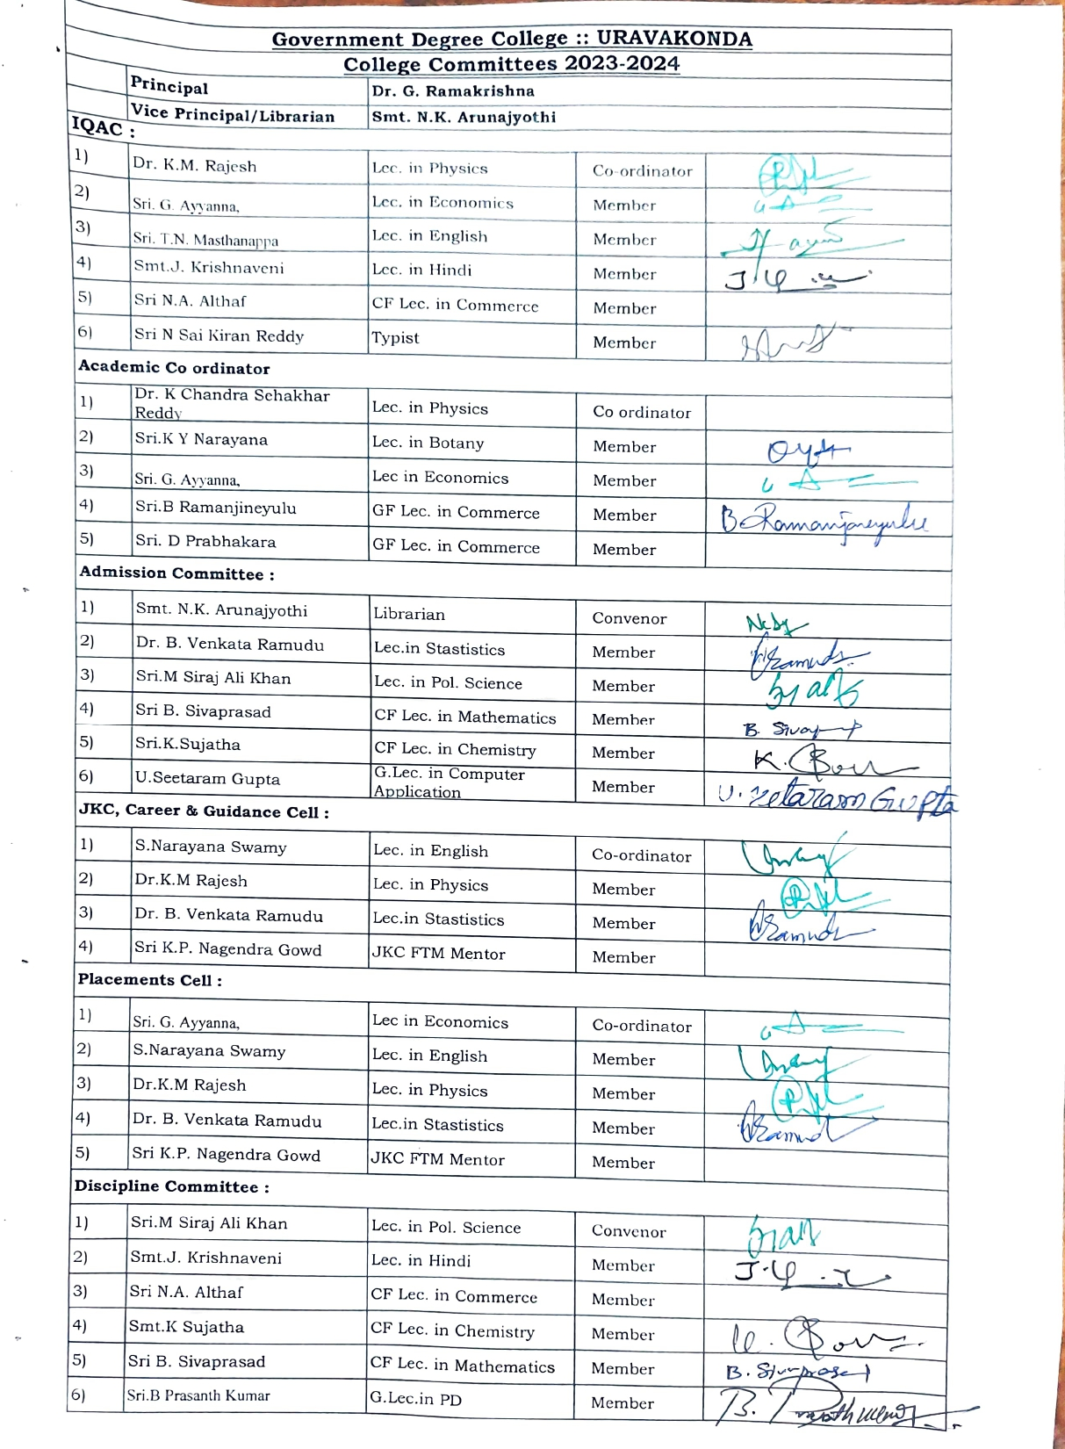**

**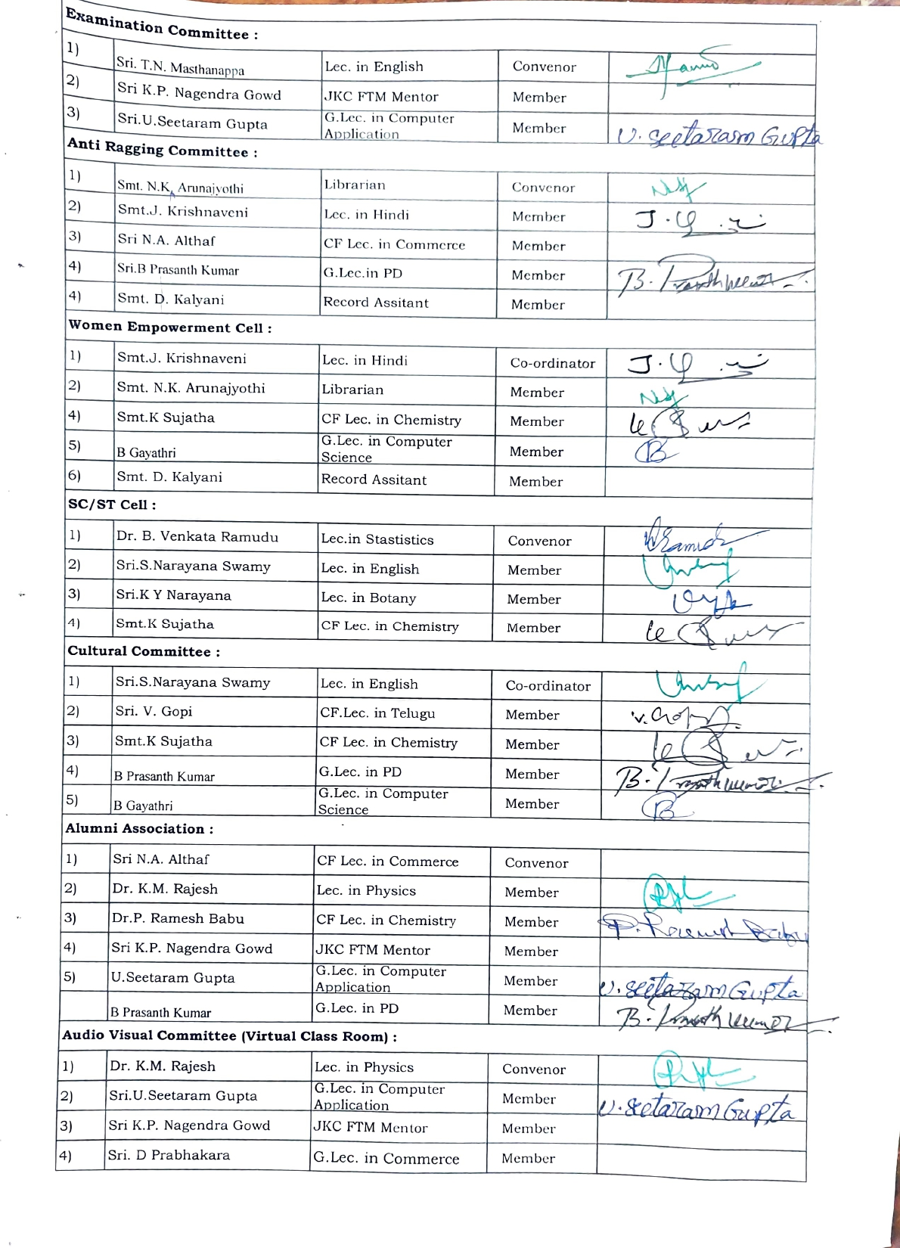**

# C:\Users\USER3~1.DES\AppData\Local\Temp\Rar$DR10.531\COLLEGE COMMITTES -2023-24 GDC, UKD_page-0003.jpg

# C:\Users\USER3~1.DES\AppData\Local\Temp\Rar$DR20.234\COLLEGE COMMITTES -2023-24 GDC, UKD_page-0004.jpg

# C:\Users\USER3~1.DES\AppData\Local\Temp\Rar$DR00.140\COLLEGE COMMITTES -2023-24 GDC, UKD_page-0005.jpg

# ONLINE CLASSES (ICT)

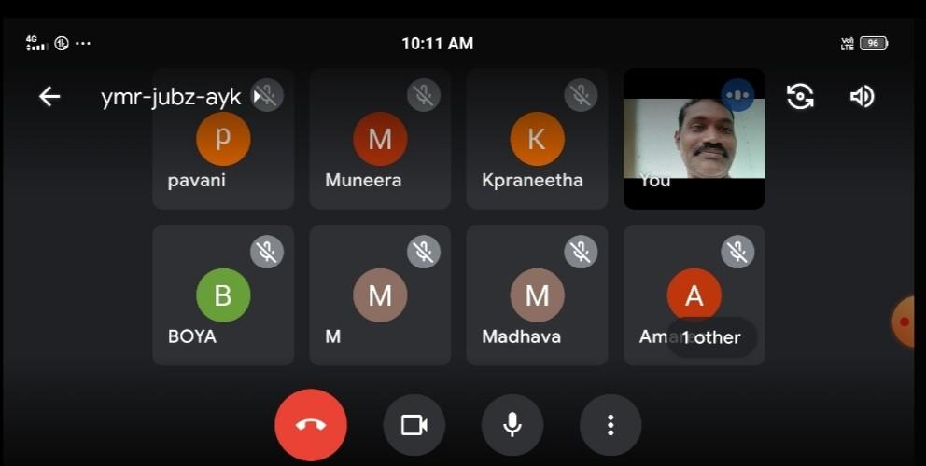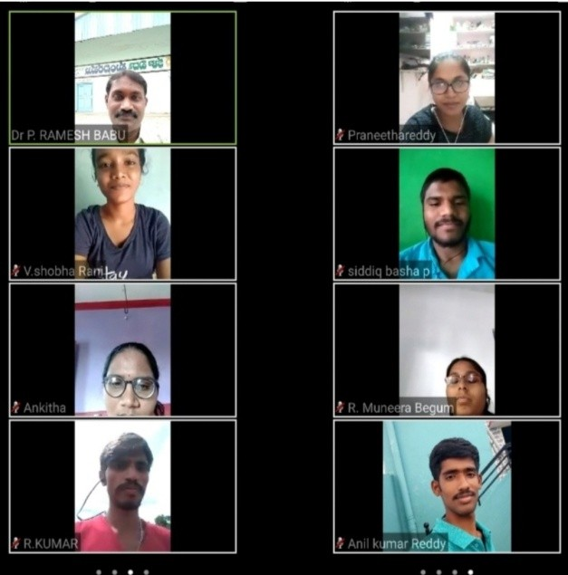

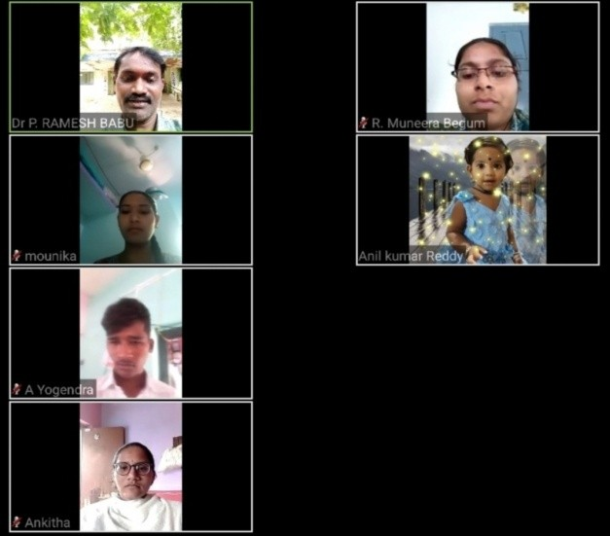 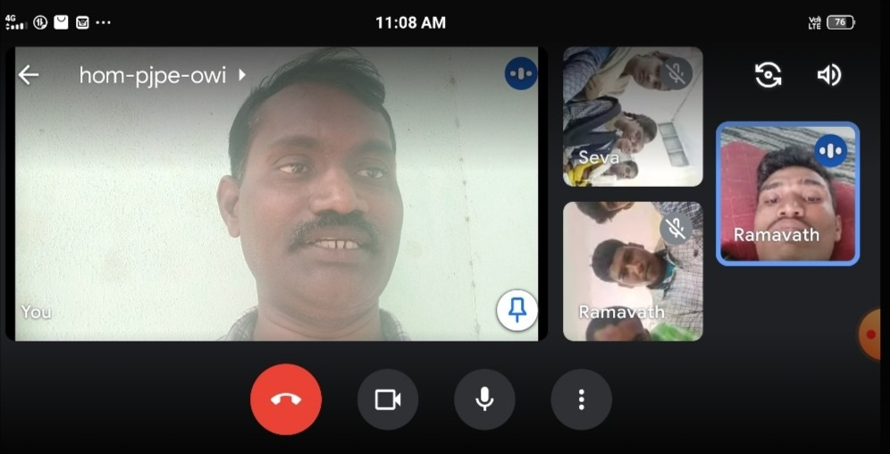

# ONLINECLASSES(ICT)

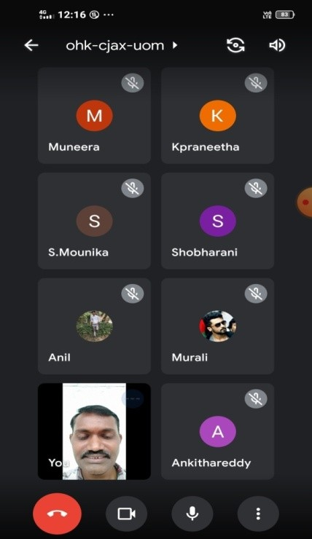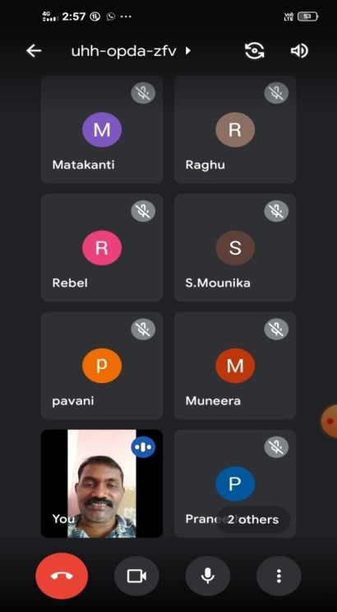

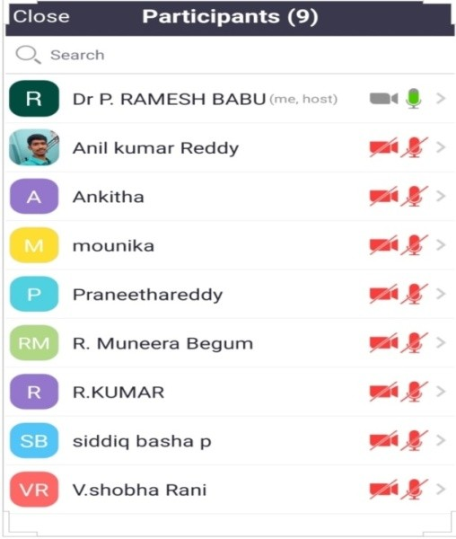

**StudentsICT/PowerPointPresentation:**

The department of Chemistry has made use of technology available in thecollege in imparting quality education to the students. Based on the pattern of the questionpaper the entire syllabus was loaded in the laptop. Later it was displayed through LCDProjector. Students actively participated in reading the displayed syllabus. It removed fear ofChemistryand enhancedtheir confidencelevelsto researchand Industrialjobs.

# OFFLINETHEORY&PRACTICALCLASSES

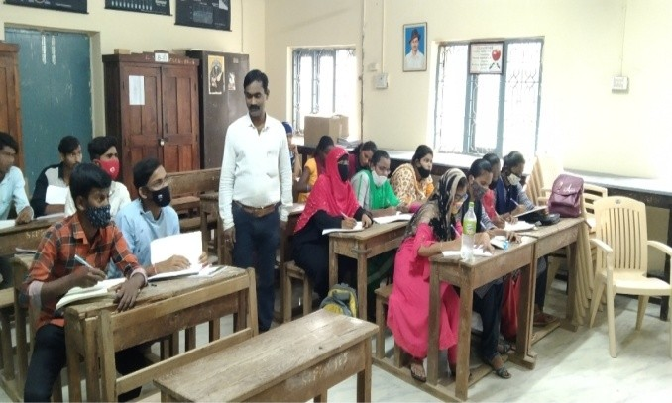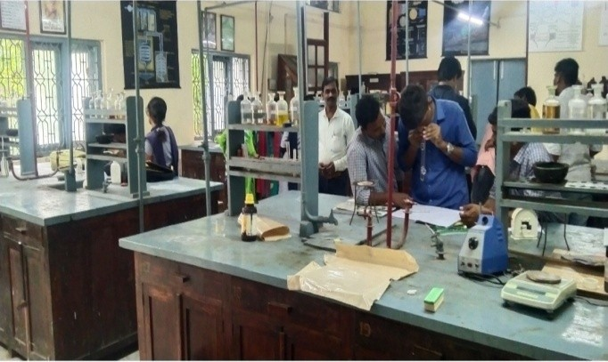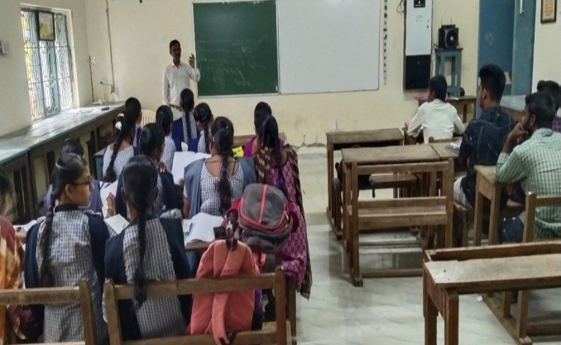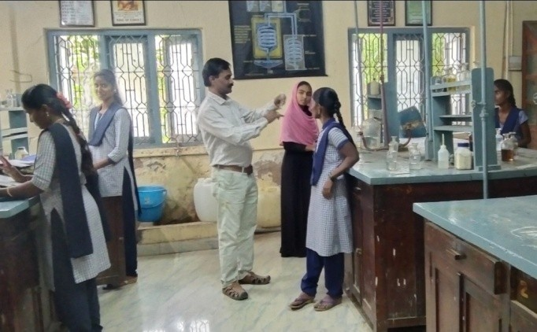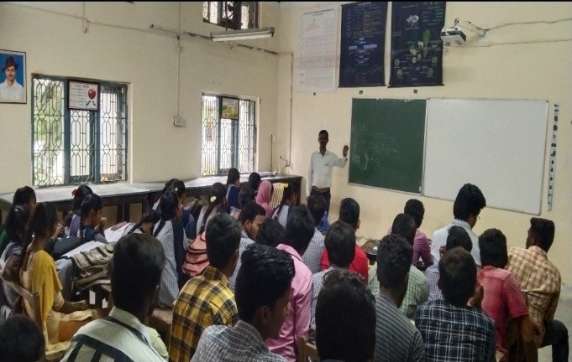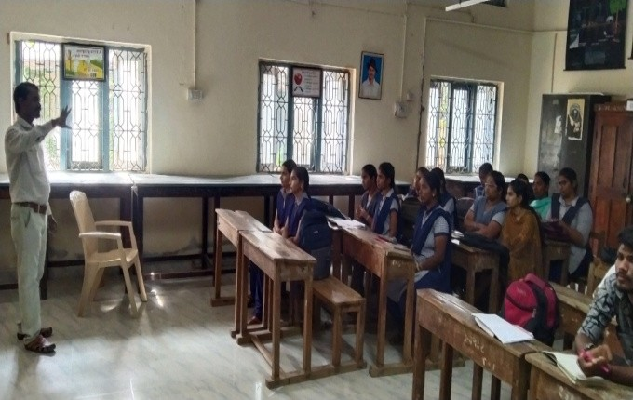

**JOURNAL PUBLICATION SINGLE sAUTHOR IMPACT FACTOR7.63**

**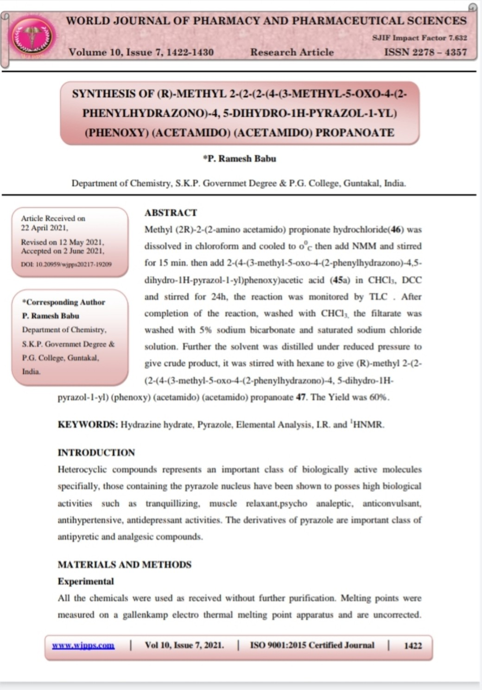**

# BOOK AUTHOR (Dr.P.RAMESHBABU)

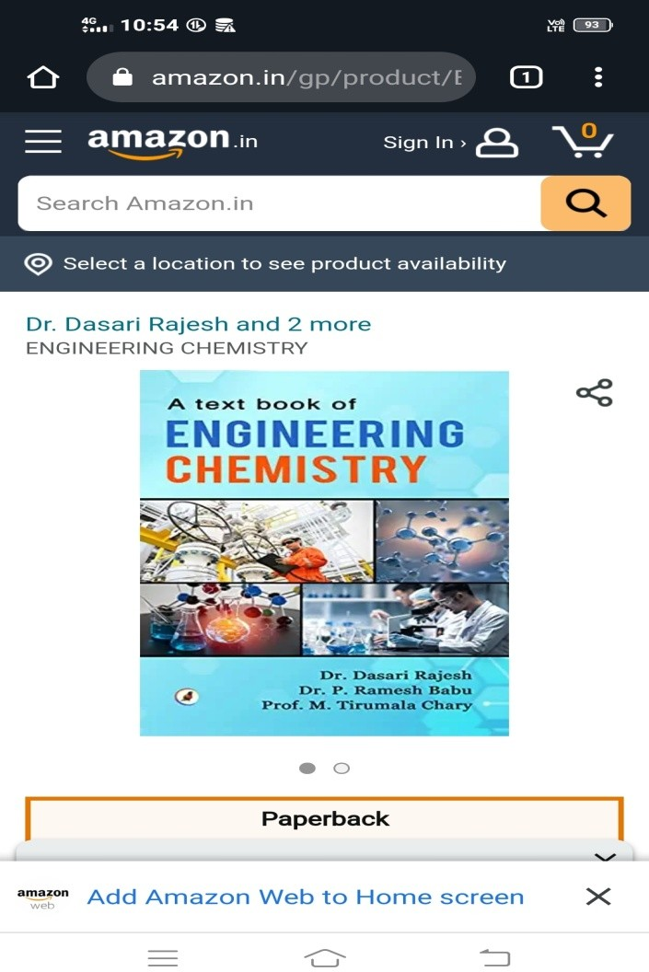

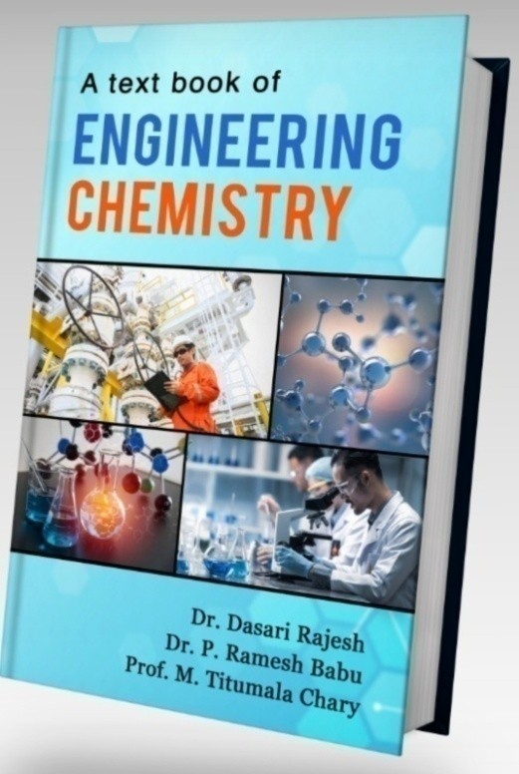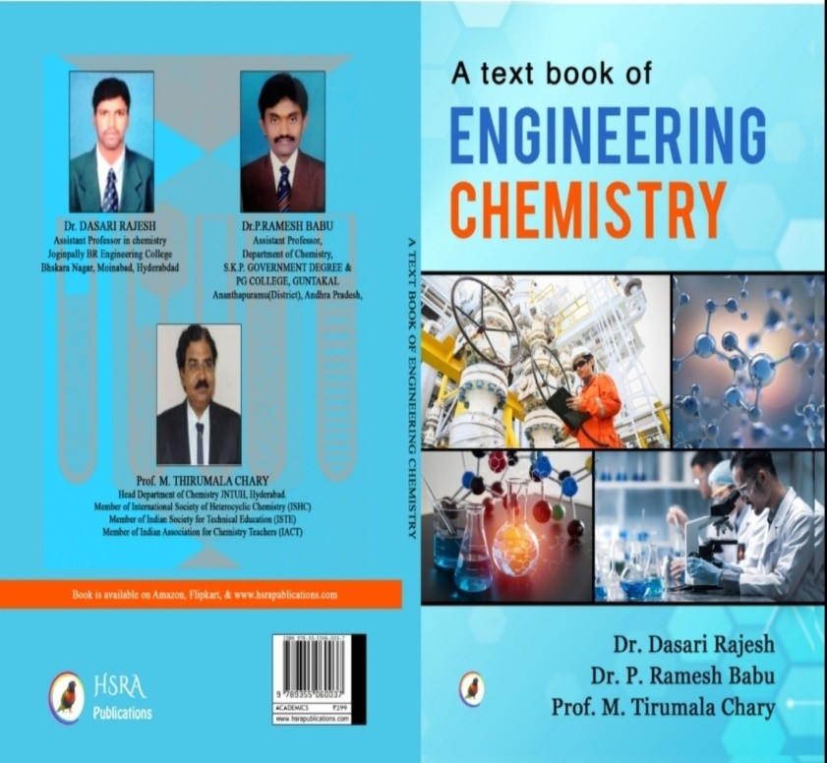

**S.K.U UG, SEMESTER EXTERNAL PRACTICALS EXAMINATION DUTY**

**AT**

**MAHATMADEGREECOLLEGE,URAVAKONDA**

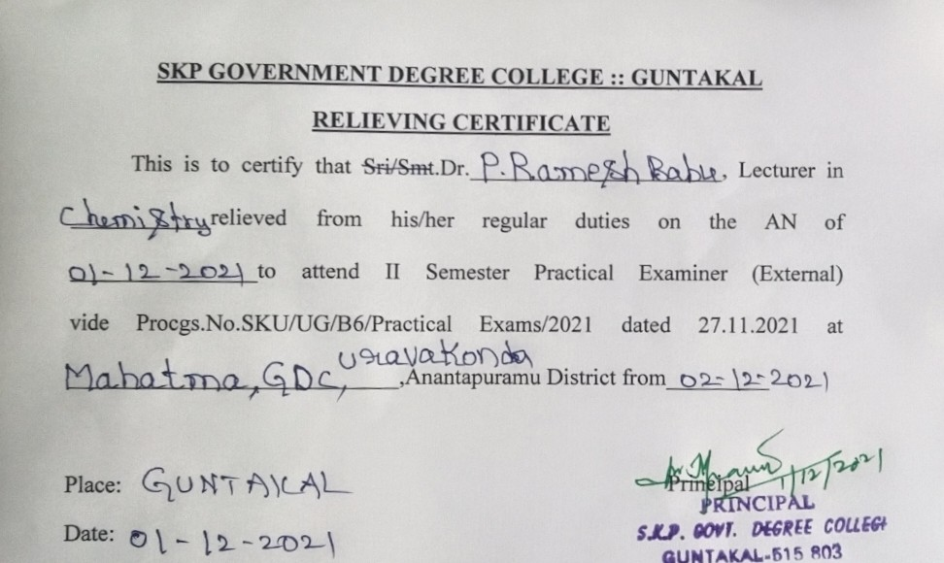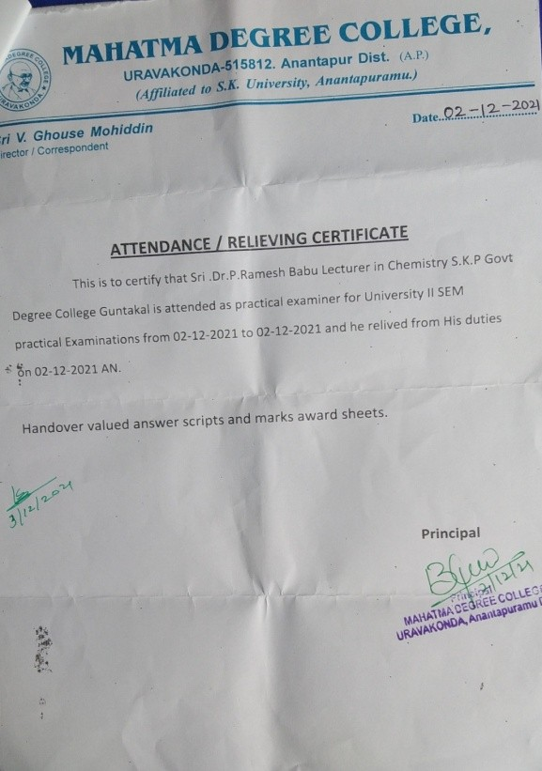

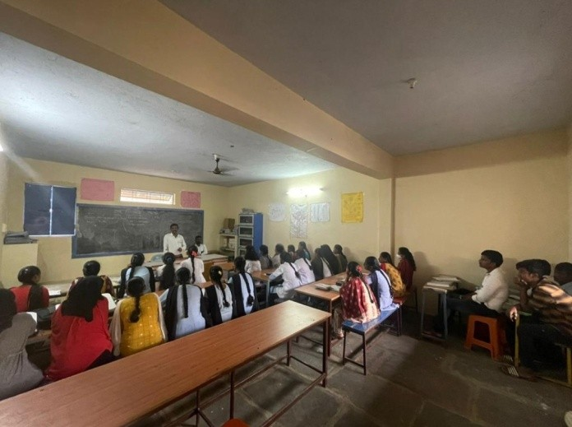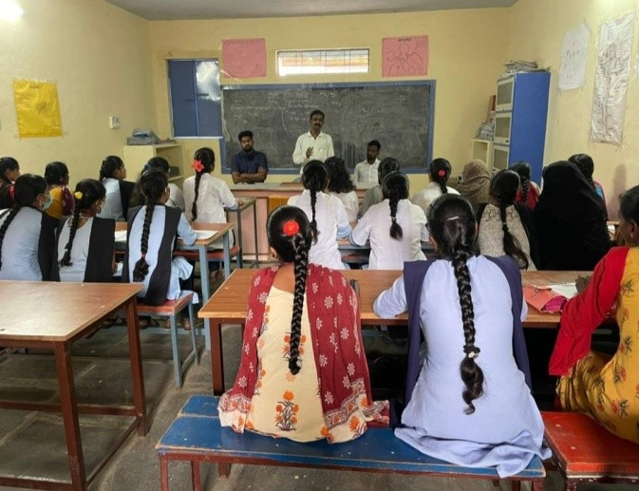

# S.K.U.UG, SEMESTER EXTERNAL THEORY EXAMINATION DUTY

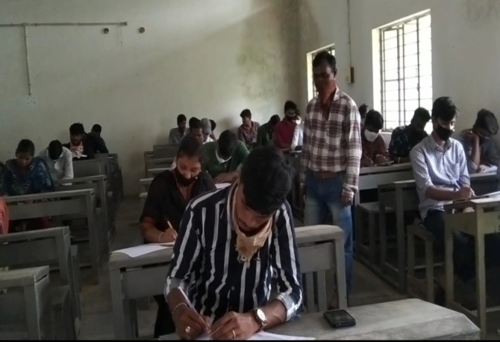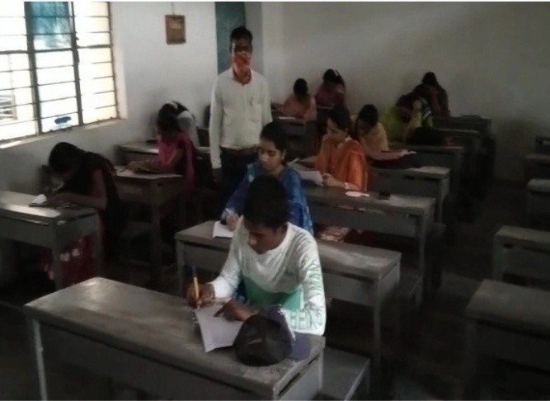

**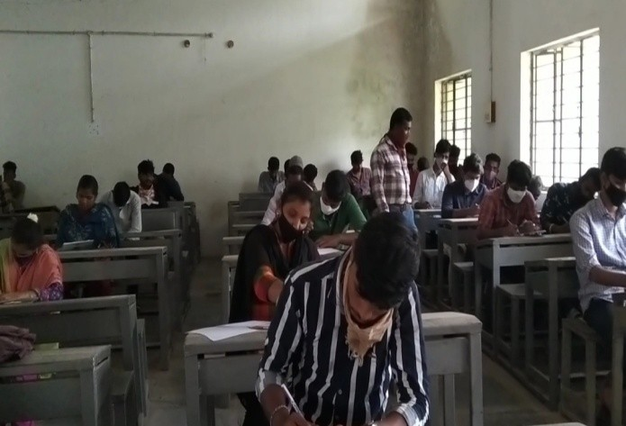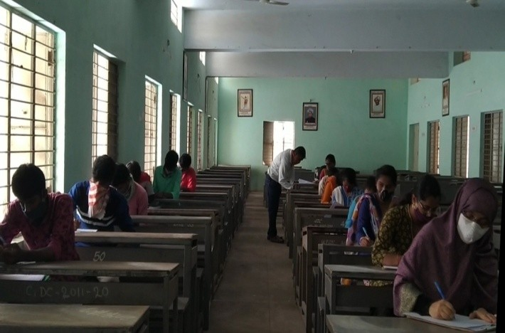**

**S.K.U.UGSEMESTERTHEORYSPOTVALUATIONDUTY**

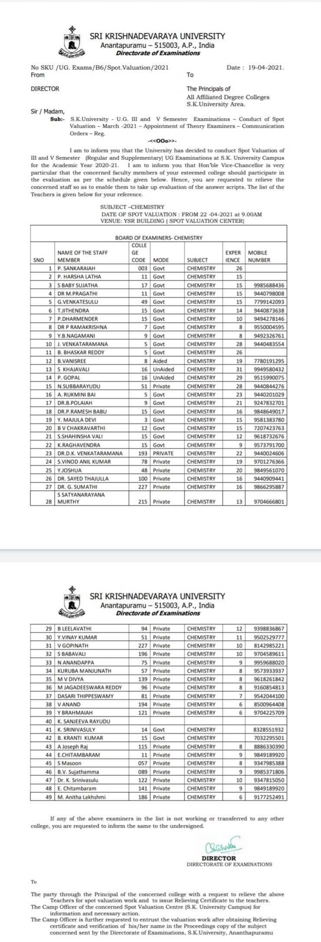

# EXTESION LECTURER AT MAHATMA DEGREE COLLEGE,URAVAKONDA

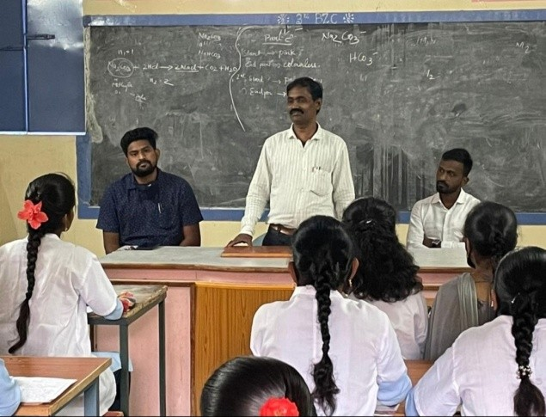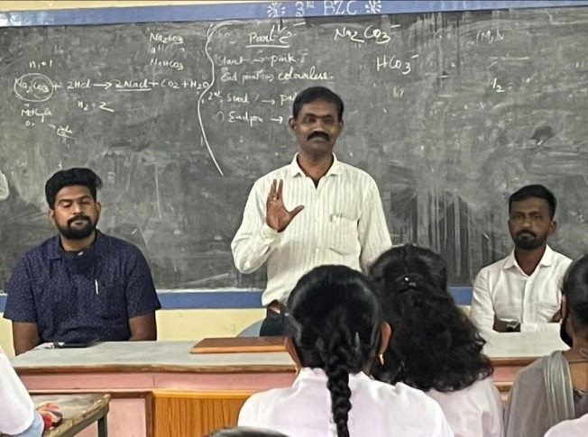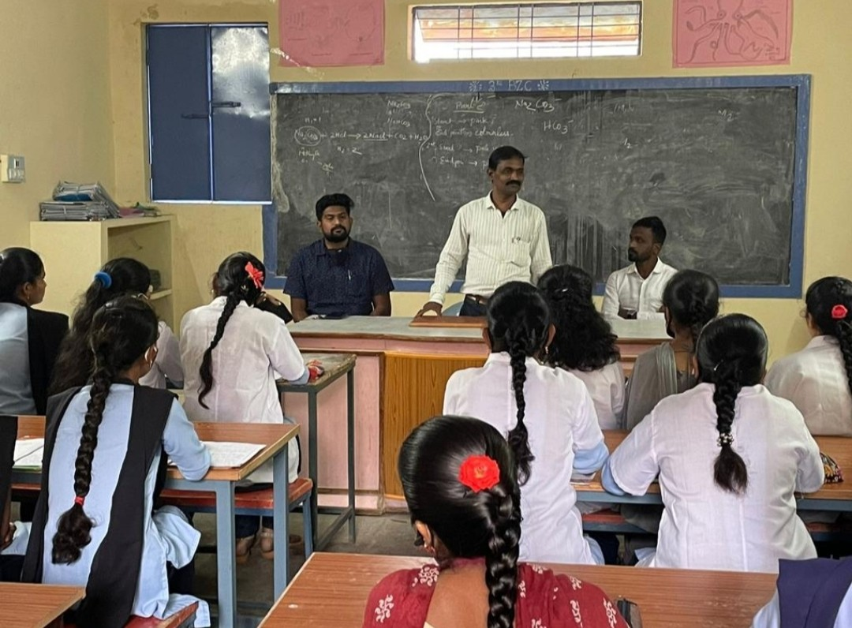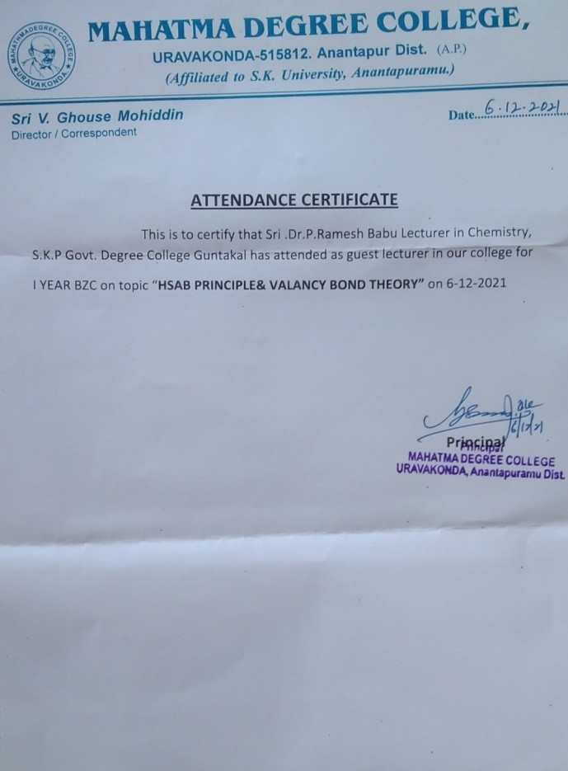

**ExtensionLecturesbytheFacultyoftheDepartment**

|  |  |  |  |  |
| --- | --- | --- | --- | --- |
| **S.No** | **NameoftheLecturer** | **Institution** | **Topic** | **Date** |
| 1 | Dr.P.RameshBabu | Extension Lecture tostudents on : NonRenewableresources | S.S.G.S. Aided DegreeCollegeGuntakal,  AnanthapuramDist,A.P. | 15/3/2018 |
| 2 | Dr.P.RameshBabu | Extension Lecture tostudentson:Basicsof  OrganicChemistry | PVKK Degree College,Anantapur | 12/8/2019 |
| 3 | Dr.P.RameshBabu | Extension Lecture to Staffon: ResearchBased  PedagogicalTools | S.S.G.S. Degree CollegeGuntakal,  AnanthapuramDist,A.P. | 15/3/2018 |
| 4 | Dr.P.RameshBabu | Extension Lecture tostudents on : BasicPrinciplesofGreen  Chemistry | PVKK Degree College,Anantapur | 27/2/2020 |
| 5 | Dr.P.RameshBabu | Chief Guest on ScienceExpo-2019 | Sri ChaitanyaSchool(Branch-2),Guntakal | Dec,2018 |
| 6 | Dr.P.RameshBabu | Chief Guest on NASAProject,2019in | Sri Chaitanya TechnoSchool,ThilakNagar,  Guntakal | Dec,2019 |
| 7 | Dr.P.RameshBabu | Guntakal Chief Guest onScienceExpo-2020 | SriChaitanyaTechno  School, Thilak Nagar,Guntakal | Jan,2020 |
| 8 | Dr.P.RameshBabu | Guest Lecture onOrganicChemistry | K.S.N. Women DegreeCollege,  Ananthapuramu | May.2021 |
| 9 | Dr.P.RameshBabu | GuestLectureon  OrganicChemistry | Sreedevi DegreeCollege,Kalyandurg | July,2022 |

# ATTENDED TO INTERNATIONAL, FDP & NATIONAL WEBINARS

